Nutritional Analysis of Junk Food: A Data Analytics Study

1. Project Overview
This project focuses on analyzing the nutritional composition of junk food items using Python for Data Analytics. The dataset is cleaned, transformed, and explored to understand nutritional patterns across food items. The analysis prepares the data for meaningful insights and future dashboard-based visualization.

2.Data Source:
OpenIntro Data Repository – Fast Food Dataset. The dataset is publicly available and not time-bound.
Organization: OpenIntro (Educational Organization)
Link: https://openintro.org/data/index.php?data=fastfood
Domain:
Healthcare (Nutrition & Public Health Analytics)
The dataset was uploaded to GitHub and imported into Google Colab using the raw GitHub URL for analysis.

3.Problem Statement
- Junk food items differ widely in their nutritional composition, making it difficult to understand their health impact.
- High calorie and nutrient imbalance in junk food can contribute to unhealthy dietary patterns.
- Nutritional values of food items are often overlooked when choosing between veg and non-veg options.
- There is a need to organize and analyze nutritional data to clearly identify calorie-heavy and nutrient-poor food items.

4.Objectives
- To analyze nutritional data of junk food items across different shops
- To understand product distribution by category (Veg/Non-Veg)food
- To compare nutritional values across shops and product categories
- To identify patterns and variations in nutritional attributes among products
- To examine the distribution of nutritional values across product types
- To perform comparative analysis of nutritional content between shop.

5. Attribute (Column / Features) Details
Attribute Name | Data Type | Description
Item | Text | Name of the junk food item
Restaurant | Text | Name of the restaurant/brand
Calories | Numeric | Total calorie content of the food item
Protein | Numeric | Protein content (Micro-nutrient)
Fiber | Numeric | Fiber content (Micro-nutrient)
Vitamin_A | Numeric | Vitamin A content (Micro-nutrient)
Vitamin_C | Numeric | Vitamin C content (Micro-nutrient)
Calcium | Numeric | Calcium content (Micro-nutrient)
Total_Fat | Numeric | Total fat content (Macro-nutrient)
Saturated_Fat | Numeric | Saturated fat content (Macro-nutrient)
Trans_Fat | Numeric | Trans fat content (Macro-nutrient)
Cholesterol | Numeric | Cholesterol content (Macro-nutrient)
Sodium | Numeric | Sodium content (Macro-nutrient)
Total_Carb | Numeric | Total carbohydrate content (Macro-nutrient)
Sugar | Numeric | Sugar content (Macro-nutrient)
Food_Category | Categorical | Veg / Non-Veg classification (Derived using regex)
Calorie_Level | Categorical | Low / Medium / High calorie category (Derived using conditional logic)

6. Tools & Technologies
- Python (Google Colab):
Data loading, cleaning, preprocessing, analysis, and visualization
- Libraries Used:
Pandas, NumPy, Matplotlib, Seaborn

7. Data Pre-Processing (Python / Pandas)
Tasks Performed:
- Removed duplicate records to avoid redundancy
- Verified data types of all columns
- Created derived columns (Food_Category and Calorie_Level) to support easier analysis and visualization
- Handled missing nutritional values using category-wise median imputation based on Food_Category
- Rechecked missing values to ensure data completeness

8.Exploratory Data Analysis (EDA)
Exploratory Data Analysis was performed to understand the distribution and behaviour of nutritional variables across junk food items. Statistical summaries and visualizations were used to examine central tendency, spread, skewness, and variability of calories, macro-nutrients, and micro-nutrients.
Initial inspection included:
- Data Frame structure (info())
- Statistical summary (describe ())
- Null value verification
- Duplicate validation

9. Analysis and Visualizations
A. Statistical Analysis
Statistical analysis was performed to understand the distribution, variability, and overall behaviour of nutritional attributes within the dataset. This section focuses on examining central tendency, dispersion, and distribution shape of calories, macro-nutrients, and micro-nutrients.
The following statistical measures were computed:
- Mean, Median, and Mode to evaluate central tendency.
- Variance and Standard Deviation to measure dispersion and variability.
- Percentile distribution (Quartiles) to understand spread and interquartile range.
- Skewness and Kurtosis to analyze distribution shape and presence of outliers.
To visually validate these statistical findings, the following charts were used:
- Histogram plots with mean and median lines for central Tendency and Skewness
- Box plots to identify spread and extreme values
- Density plots to examine distribution shape
This statistical foundation supports the subsequent univariate, bivariate, and multivariate analyses by establishing clear numerical patterns in the dataset
  - Micro-Nutrients – Statistical Analysis
Micro-nutrients including protein, fiber, vitamins, and calcium were analyzed to evaluate the nutritional balance of junk food items. Statistical measures were used to assess their distribution, variability, and relative contribution. This section helps understand the quality aspect of nutrition beyond calorie content. The below table gives the statistical summary of Micro-Nutrients.

Table 1: Statistical Summary of Micro-Nutrients
Micro  Nutrient | Mean | Median | Mode | Max | Variance | Standard Deviation | Skewness | Kurtosis
protein | 27.91 | 25 | 1 | 186 | 313.13 | 17.69 | 2.80 | 16.46
fiber | 4.10 | 3 | 2 | 17 | 9.044 | 3.00 | 1.43 | 2.19
vit_a | 15.63 | 10 | 10 | 180 | 592.58 | 24.34 | 5.55 | 34.22
vit_c | 16.28 | 12.5 | 12.5 | 400 | 579.83 | 24.07 | 9.20 | 131.58
calcium | 21.83 | 15.5 | 15.5 | 290 | 402.16 | 20.05 | 5.75 | 63.74

Figure1: Histplot -Measure of Central Tendency of Micro-Nutrients
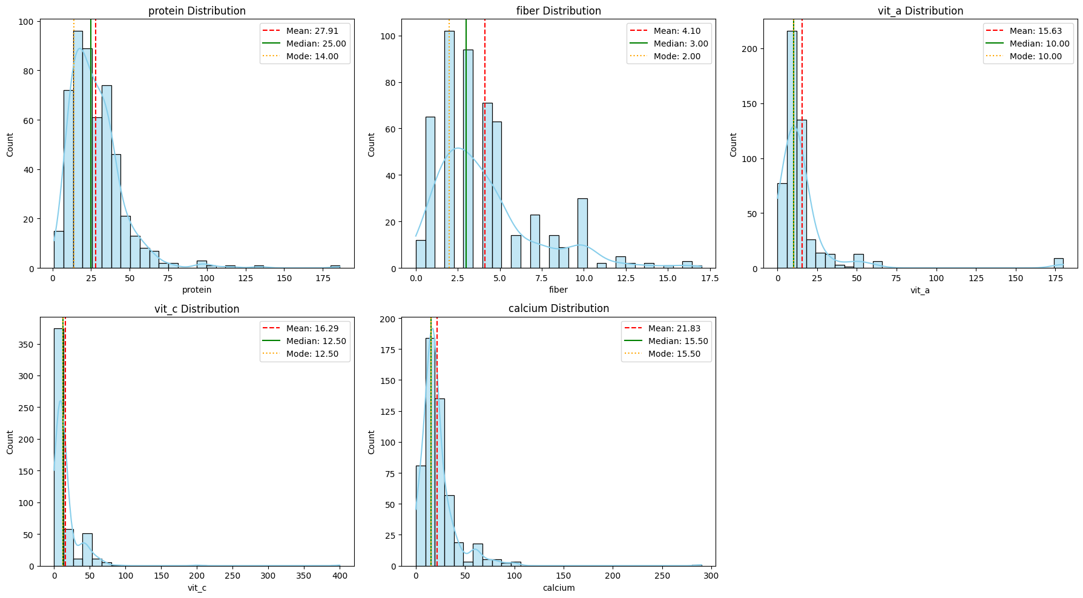
Figure 2: Histplot - Micro-Nutrients: Measure of Distribution using Skewness
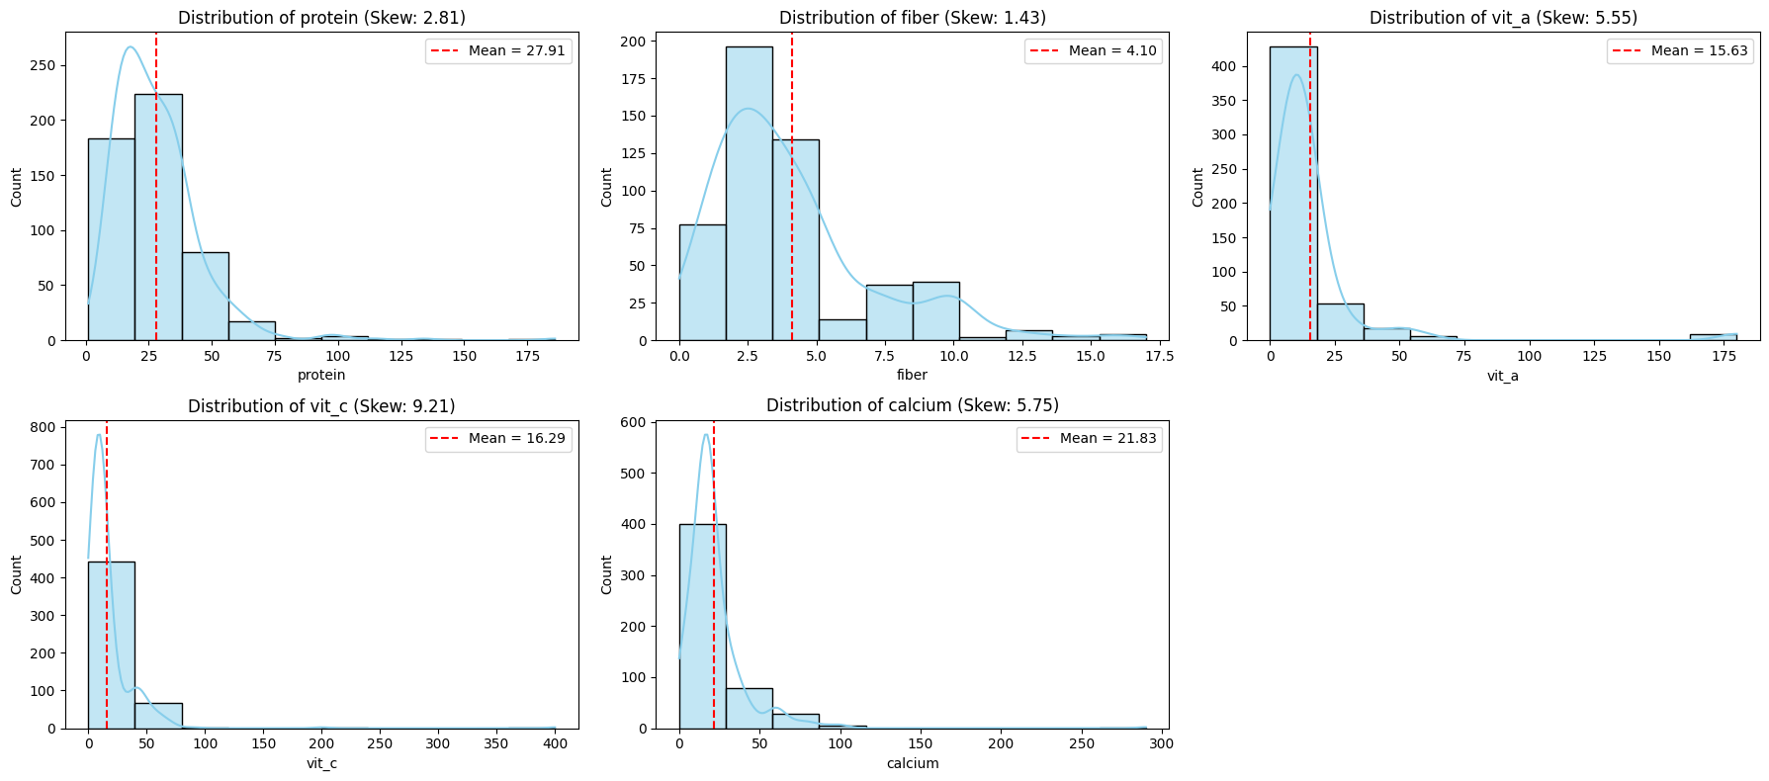

Figure 3: Krutosis -KDE/Density chart of Micro-Nutrients: Measure of Distribution

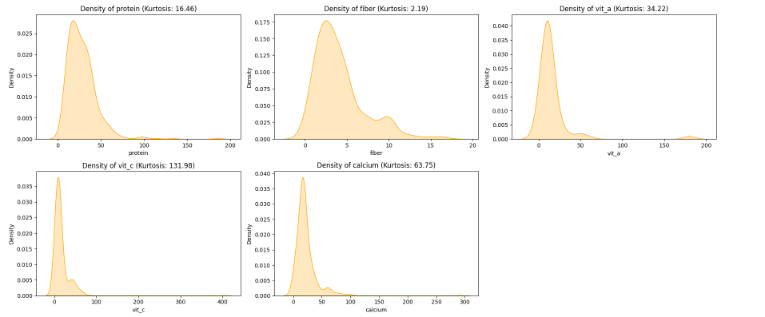

Percentile Analysis – Micro-Nutrients

Percentile analysis for micro-nutrients was performed to assess their distribution across food items. The quartile values provide insight into the central spread and variation of nutrients such as protein, fiber, vitamins, and calcium. This helps evaluate nutritional balance prior to interpreting box plot representations. The below table gives the percentile distribution of Micro-Nutrients

Table 2: Percentile Distribution of Micro-Nutrients
Percentile | protein | fiber | vit_a | vit_c | calcium
25 % | 16 | 2 | 10 | 8 | 15
50 % | 25 | 3 | 10 | 12.5 | 15.5
75 % | 36 | 5 | 15 | 15 | 25

Figure 4: Box Plot Representing Percentile Distribution and Spread of Micro-Nutrients
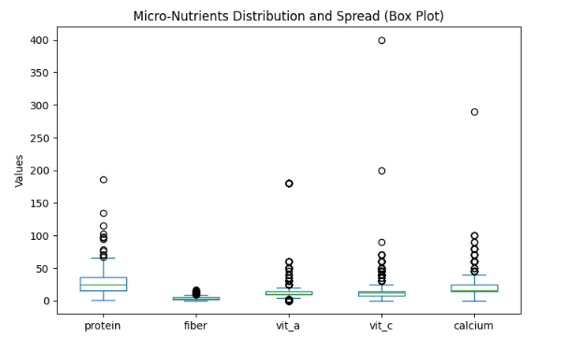

Interpretation of Micro-Nutrients

- Micro-nutrients show comparatively lower central tendency values.
- Variance and standard deviation are lower than macro-nutrients.
- Distribution spread is moderate with fewer extreme outliers.
- Skewness indicates limited asymmetry compared to macro-nutrients.
- Micro-nutrients contribute less to overall nutritional composition.
- Highlights imbalance between macro and micro nutrients.
- Supports objective of evaluating nutritional quality across products.
- Indicates potential nutritional deficiency in junk food items.

B.Macro-Nutrients – Statistical Analysis

Macro-nutrients such as total fat, sugar, sodium, and cholesterol significantly contribute to calorie content. Statistical evaluation of macro-nutrients was conducted to examine their central tendency, dispersion, and distribution characteristics. This analysis helps identify key nutritional drivers influencing calorie density and overall food quality.The below table gives the statistaitcal summary of Macro-Nutrients

Table 2: Statistical Summary of Macro-Nutrients

Macro  Nutrient | Mean | Median | Mode | Max | Variance | Standard Deviation | Skewness | Kurtosis
cal_fat | 238.94 | 210 | 160 | 1270 | 27783.32 | 166.68 | 1.77 | 5.50
total_fat | 26.60 | 23 | 18 | 141 | 340.13 | 18.44 | 1.78 | 5.57
sat_fat | 8.15 | 7 | 4 | 47 | 41.36 | 6.43 | 2.02 | 6.17
trans_fat | 0.46 | 0 | 0 | 8 | 0.70 | 0.840 | 3.016 | 15.30
Cholesterol | 72.55 | 60 | 40 | 805 | 4001.76 | 63.25 | 4.41 | 38.76
sodium | 1247.30 | 1110 | 1120 | 6080  (Min-15) | 477699.09 | 691.15 | 1.80 | 6.68
total_carb | 45.64 | 44 | 44 | 156 | 621.20 | 24.92 | 0.80 | 0.81
Sugar | 7.27 | 6 | 7 | 87 | 45.83 | 6.770 | 4.60 | 42.18

Figure 5 : Histplot -Measure of Central Tendency of Macro-Nutrients
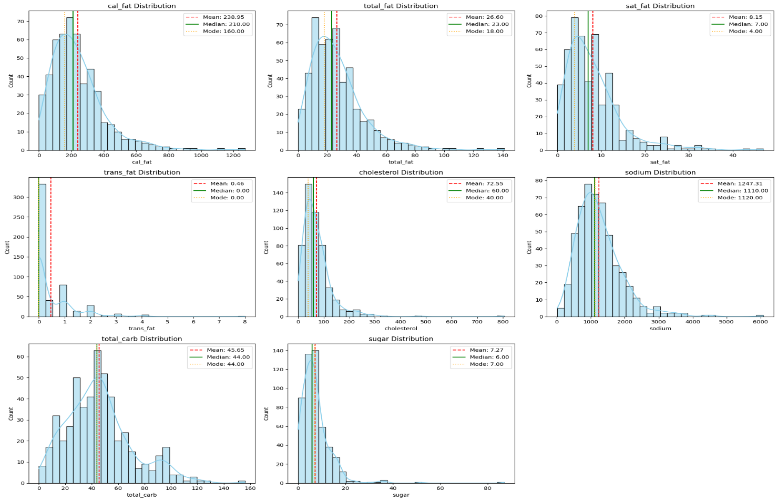
Figure 6 : Histplot - Micro-Nutrients: Measure of Distribution using Skewness
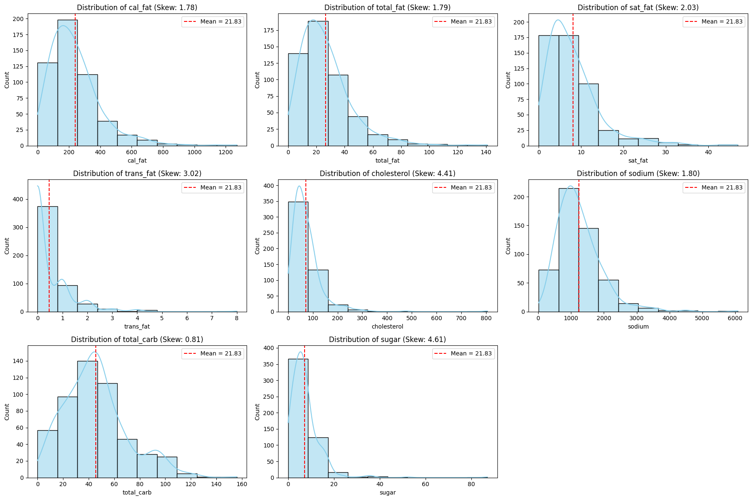

Figure 7: Krutosis -KDE/Density chart of Macro-Nutrients: Measure of Distribution

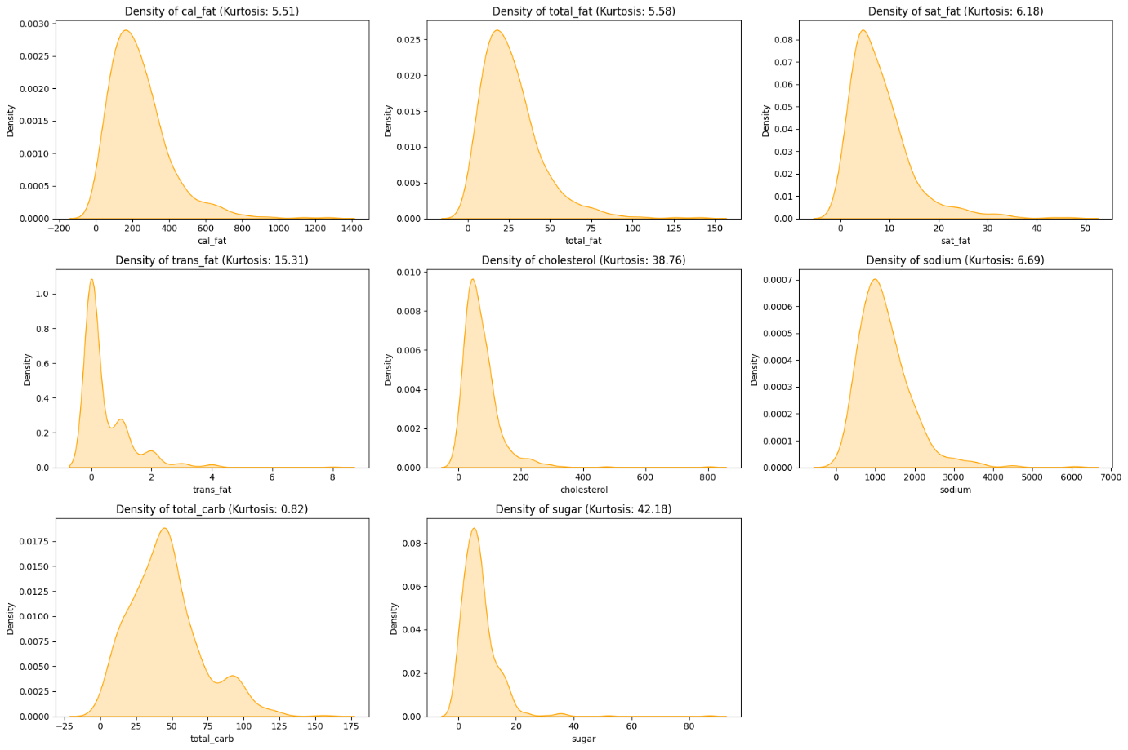
Percentile Analysis – Macro-Nutrients
Percentile distribution was examined for macro-nutrients to evaluate the spread and concentration of fat, sugar, sodium, and cholesterol values. The quartile measures help identify variability within the middle 50% of observations and highlight the presence of extreme values. This supports deeper understanding of macro-nutrient dispersion before box plot visualization. The below table and boxplot show percentile distribution of Macro-Nutrients

Table 3: Percentile Distribution of Micro-Nutrients
Percentile | cal_fat | total_fat | sat_fat | trans_fat | cholesterol | sodium | total_carb | sugar
25% | 120 | 14 | 4 | 0 | 35 | 800 | 28 | 3
50% | 210 | 23 | 7 | 0 | 60 | 1110 | 44 | 6
75% | 310 | 35 | 11 | 1 | 95 | 1550 | 57 | 9

Figure 8: Box Plot Representing Percentile Distribution and Spread of Macro-Nutrients

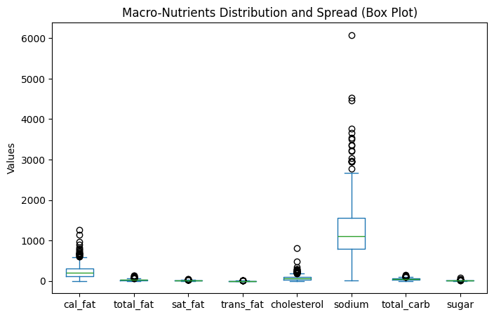

Interpretation of Macro-Nutrients

- Macro-nutrients (fat, sugar, sodium) show high variability.
- Mean > Median in several variables indicates right-skewed distribution.
- Standard deviation values are relatively high, confirming dispersion.
- Boxplots reveal multiple extreme outliers.
- Skewness and kurtosis suggest heavy-tailed distributions.
- Macro-nutrients strongly influence calorie density.
- High-fat and high-sugar items contribute to unhealthy patterns.
- Supports objective of identifying nutritional drivers of calories.
- Confirms variation across products and restaurants.

C. Calories – Statistical Analysis
Calories serve as the primary outcome variable in this study, representing the overall energy content of junk food items. Statistical analysis of calories was performed to understand distribution patterns, variability, and the presence of extreme high-calorie values. This analysis helps identify unhealthy nutritional patterns and supports comparative evaluation across products and restaurants. The below table gives statistical summary of Calories.

Table 4: Statistical Summary of Macro-Nutrients

Calories | Mean | Median | Mode | Min | Max | Variance | Standard Deviation | Skewness | Kurtosis
Values | 531.11 | 490 | 350 | 20 | 2430 | 80032.55 | 282.90 | 1.41 | 4.69

Figure 9: Histplot -Measure of Central Tendency of Calories

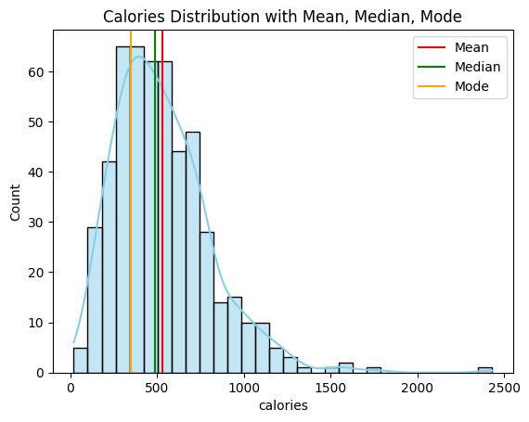

Figure 11: Histplot -Calories: Measure of Distribution using Skewness
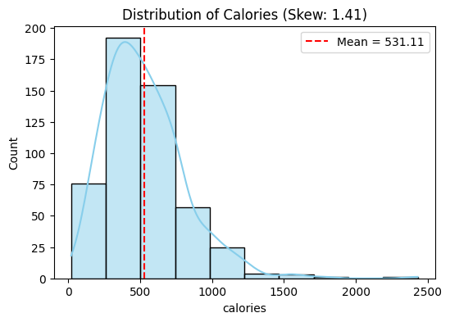

Figure 12: Krutosis -KDE/Density chart of Calories: Measure of Distribution

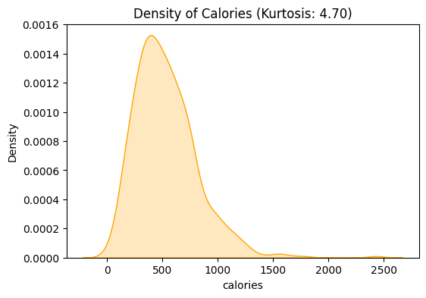

Percentile Analysis – Calories
Percentile analysis was conducted to understand the spread and distribution of calorie values across food items. The 25th, 50th (median), and 75th percentiles help identify the interquartile range and concentration of typical calorie values. This provides a clearer understanding of distribution spread before visualizing variability through the box plot. The below table and box plot gives percentile distribution of calories
Table 5 : Percentile Distribution of Calories
Percentile | calories
25 % | 330
50 % | 490
75 % | 690

Figure 13 : Box Plot Representing Percentile Distribution and Spread of Calories

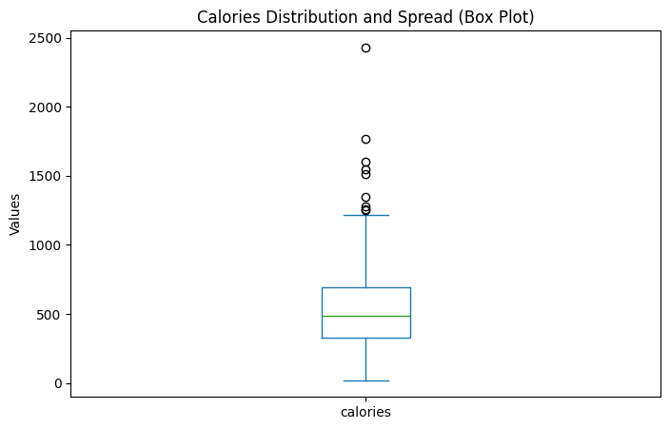

Interpretation for Calories
- Mean is slightly higher than median, indicating positive skewness.
- Histogram shows right-tailed distribution with extreme high-calorie values.
- High variance and standard deviation confirm wide dispersion.
- Boxplot identifies clear high-calorie outliers.
- Skewness and kurtosis values indicate heavy-tailed distribution.
- Presence of extreme high-calorie items supports identification of unhealthy patterns.
- Significant variability confirms nutritional differences across junk food items.
- Calorie distribution analysis helps compare product health impact.

Overall findings from statistical analysis:
- Calories exhibit positive skewness.
- Macro-nutrients show high variability.
- Micro-nutrients are relatively lower and less dispersed.
- Significant outliers exist in calorie and fat values.
The statistical distribution patterns observed above are visually validated in the univariate, bivariate, and multivariate analyses presented below

B. Variate Analysis for Visualization
Following the statistical evaluation, variate analysis was performed to visually explore patterns and relationships within the dataset. This stage includes univariate, bivariate, and multivariate analyses to understand individual variable behaviour, relationships between nutritional attributes, and combined interactions across restaurants and food categories.
Univariate analysis focuses on the distribution of single variables, bivariate analysis examines relationships between two variables, and multivariate analysis explores interactions among multiple nutritional factors simultaneously. These visual analyses help validate statistical findings and support objective-based insight

1.Univariate Analysis
Univariate analysis was performed to examine the distribution and behavior of individual nutritional variables independently. This includes analyzing calories, food categories, and nutrient values to understand their frequency distribution, spread, and overall patterns. The purpose of this analysis is to identify basic distribution characteristics and variability within the dataset. The following univariate visualizations were performed:
1.Distribution of Calories -Histogram
The histogram displays the frequency distribution of calorie values across all junk food items.

Figure 14: Histogram for Distribution of Calories
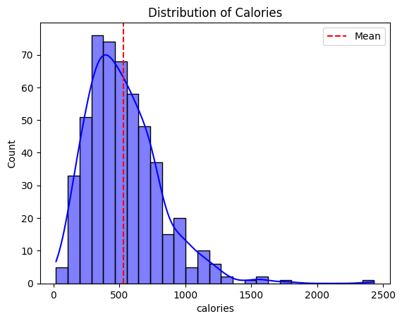

Technical Interpretation (Distribution Shape & Statistics)

- The histogram shows a right-skewed distribution, with most food items having lower to moderate calorie values.
- A long right tail indicates the presence of several high-calorie outliers.
- The mean calorie line is influenced by these high-calorie items.
- Due to skewness, the median is more representative of a typical food item’s calorie content.
- The calorie values show a wide spread, ranging from low to extremely high values.

Objective-Oriented Interpretation (Health & Nutrition Focus)

- Most junk food items fall within a moderate calorie range (approximately 200–700 calories).
- A smaller but important group of items exceeds 1000 calories, indicating calorie-dense food and unhealthy options
- These high-calorie items contribute significantly to daily energy intake.
- Identifying such items is crucial for understanding potential health risks associated with frequent junk food consumption.

Statistical Validation

The positive skewness and higher mean observed statistically are visually confirmed by the right-skewed calorie distribution in the histogram.

2. Distribution of Calorie Levels -Countplot

The countplot shows the number of food items classified under Low, Medium, and High calorie categories

Figure 15: Countplot for Distribution of Calorie Levels

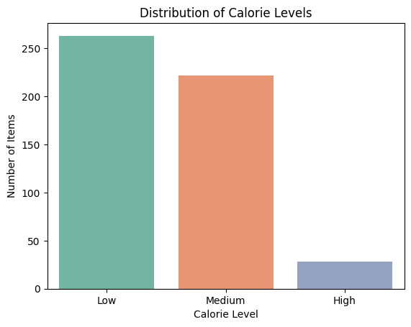

Technical Interpretation (Counts & Distribution)

- The count plot shows the frequency of food items across calorie levels: Low, Medium, and High.
- The distribution is uneven, indicating variation in calorie classification.
- Low and Medium calorie levels have higher frequencies compared to High calorie level.
- High calorie items form the smallest category in the dataset.

Objective-Oriented Interpretation (Health & Nutrition Focus)

- A majority of junk food items fall under Low (263 items) and Medium (222 items) calorie categories.
- This indicates that not all junk food items are extremely high in calories.
- High calorie items (28 items), though fewer in number, are the most calorie-dense
- Even a small number of high-calorie items can significantly impact daily calorie intake.
- The visualization highlights calorie variability within junk food products, supporting informed dietary choices.

Statistical Validation

The statistical distribution of calorie values is reflected in the dominance of low and medium categories in the countplot.

3. Distribution of Food Category (Veg / Non-Veg)-Countplot
This countplot represents the frequency distribution of Veg and Non-Veg food items in the dataset
Figure 16: -Countplot for Distribution of Food Category (Veg / Non-Veg)
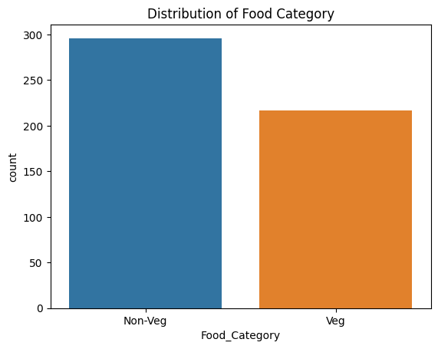

Technical Interpretation (Counts & Distribution)
- The count plot shows more Non-Veg items than Veg items in the dataset.
- There are 296 Non-Veg and 217 Veg food items.
- This indicates an uneven distribution across food categories.
Objective-Oriented Interpretation (Health & Nutrition Focus)
- Nutritional insights are more influenced by Non-Veg food characteristics.
- Veg food analysis is based on comparatively fewer data points.
- Health-related conclusions should consider this category imbalance when interpreting results.
Statistical Validation
The frequency imbalance observed numerically is clearly represented in the categorical distribution of Veg and Non-Veg items.

4.–Contribution of Key Micro-Nutritional Components- Pie Chart
The pie chart illustrates the proportional contribution of different micro-nutrients to the overall nutritional composition
Figure 17: Pie Chart for Contribution of Key Micro-Nutritional Components

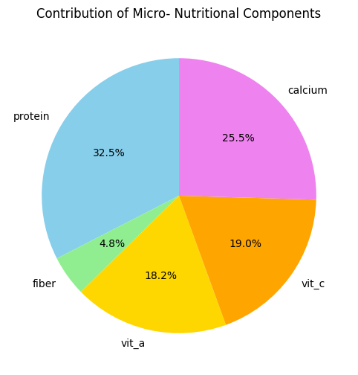

Technical Interpretation (Proportions & Dominance)
- Slice size represents the relative total of each nutrient across the dataset.
- Percentage labels enable quick comparison between nutrients.
- Color coding helps clearly distinguish each micro-nutrient.
Objective-Oriented Interpretation (Health & Nutrition Focus)
- Identifies which micro-nutrients are more prevalent in junk food items.
- Highlights lower presence of fiber and vitamins, indicating nutritional gaps
- Supports identification of nutritional patterns and imbalances.
- Contributes to understanding the overall micro-nutritional profile of junk food
Statistical Validation
The percentile and spread measures are visually supported by the proportional representation of micro-nutrient contributions.
5.Sugar Distribution (KDE Plot)
The density plot represents the distribution pattern of sugar values across junk food items.
Figure 18: KDE Plot for Sugar Distribution
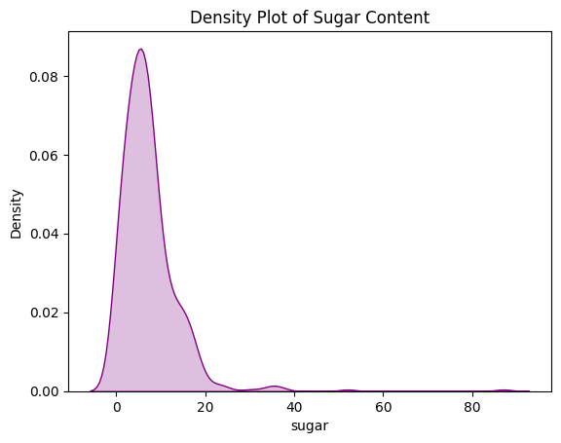

Technical Interpretation (Distribution Shape & Density)
- The KDE plot shows a right-skewed distribution of sugar content.
- Most food items have low sugar levels, with a high density at lower values.
- A smooth density curve highlights variability in sugar content across products.
Objective-Oriented Interpretation (Health & Nutrition Focus)
- A subset of food items contains very high sugar levels, posing health concerns.
- High-sugar items, though fewer, can significantly impact dietary health.
- Junk food shows wide variation in sugar content, not uniformly high.
- Supports the objective of identifying patterns and variations in nutritional attribute
Statistical Validation
The positive skewness of sugar values is visually validated by the right-tailed density distribution
These Univariate analysis visualizations helped in understanding:
- Calorie distribution patterns
- Category imbalance
- Nutritional composition proportion
- Sugar density variation

2.Bivariate Analysis
Bivariate analysis was conducted to explore relationships between two variables at a time, particularly between nutrients and calorie content. This helps identify correlation patterns, comparative differences across food categories, and restaurant-wise variation. The objective is to understand how one nutritional factor influences another. The following bivariate comparisons were conducted.
1.Average Calories – Veg vs Non-Veg (Grouped Bar Chart)
The grouped bar chart compares the average calorie values between Veg and Non-Veg food categories.

Figure 19: Grouped Bar Chart for Average Calories – Veg vs Non-Veg
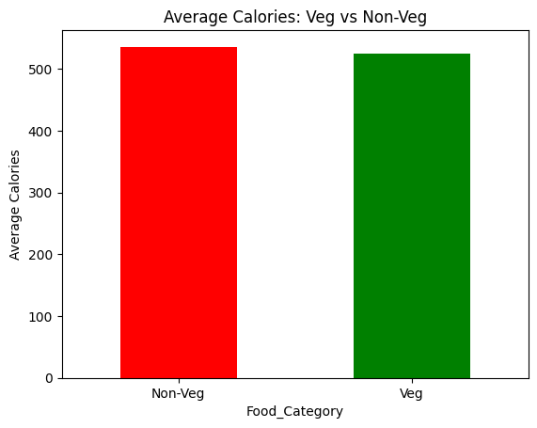
Technical Interpretation (Comparison & Trends)
- The bar chart visually compares the average calorie content between Veg and Non-Veg food categories.
- It shows a distinct difference, with Non-Veg items having a higher average calorie count than Veg items.
- The use of different colors (green for Veg, orange for Non-Veg) clearly distinguishes the two categories.
Objective-Oriented Interpretation (Health & Nutrition Focus)
- This chart indicates that, on average, Non-Veg junk food items tend to be more calorie-dense than Veg items.
- This insight is crucial for consumers and health professionals looking to manage calorie intake from junk food.
- It supports the objective of comparing nutritional values across product categories (Veg/Non-Veg) and helps identify general dietary patterns.
- For individuals aiming to reduce calorie consumption, opting for Veg options might generally lead to lower calorie intake within this dataset.
Statistical Validation
The difference in mean calorie values between categories is directly reflected in the grouped bar comparison.

2. High-Calorie Food Items (≥1500 Calories)
The bar chart highlights food items with extremely high calorie values exceeding 1500 calories.
Figure 20: Bar Chart for High-Calorie Food Items (≥1500 Calories)
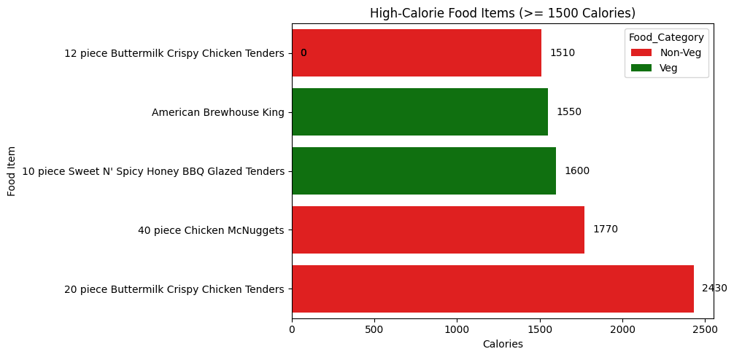
Technical Interpretation (High-Calorie Comparison)
- The bar chart displays food items with 1500+ calories, sorted in descending order.
- Bar height represents the calorie value of each item.
- Color coding differentiates Veg and Non-Veg items for quick comparison.
- Rotated x-axis labels improve readability of item names.
Objective-Oriented Interpretation (Nutritional Outliers)
- Clearly identifies extremely high-calorie junk food items.
- Highlights foods that contribute most to excess calorie intake.
- Shows that both Veg and Non-Veg categories contain high-calorie items.
- Helps pinpoint calorie-dense products for health-focused analysis and decision-making.
Statistical Validation
The extreme range and high standard deviation observed statistically are confirmed by the presence of outlier high-calorie items

3. Average Calories by Restaurant
This bar chart compares the average calorie content across different restaurant

Figure 21: Bar Chart for Average Calories by Restaurant
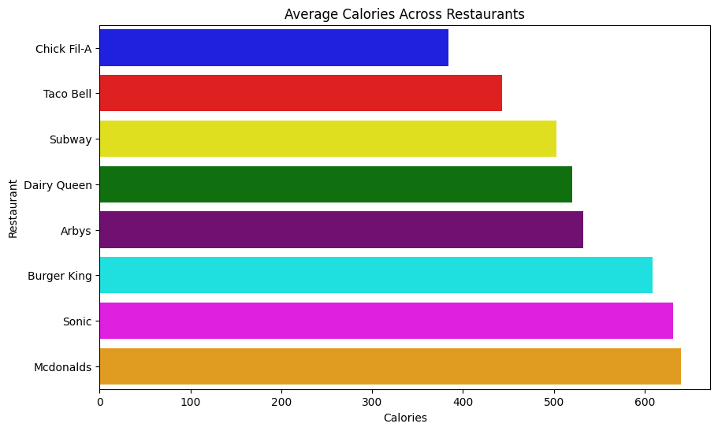
Technical Interpretation (Custom Colors & Comparison)
- A horizontal bar chart is used to compare average calories across restaurants.
- Each restaurant is assigned a distinct custom color for clear differentiation.
- Restaurants are sorted by average calorie value, enabling easy ranking.
- The x-axis represents Calories, and the y-axis lists Restaurant names.
Objective-Oriented Interpretation (Nutrition & Shop Comparison)
- Clearly compares average calorie levels across different fast-food shops.
- Helps identify restaurants offering lower vs higher calorie options.
- Supports health-focused decision-making for consumers and researchers
- Directly fulfils the objective of comparing nutritional values across shops.
Statistical Validation
The variability in calorie distribution is visually demonstrated through differing average values across restaurants.

4. Sugar vs Calories & Fat vs Calories (Subplots)
The scatter plots illustrate the relationship between sugar and calories, and between fat and calories

Figure 22: Sugar vs Calories & Fat vs Calories (Subplots)
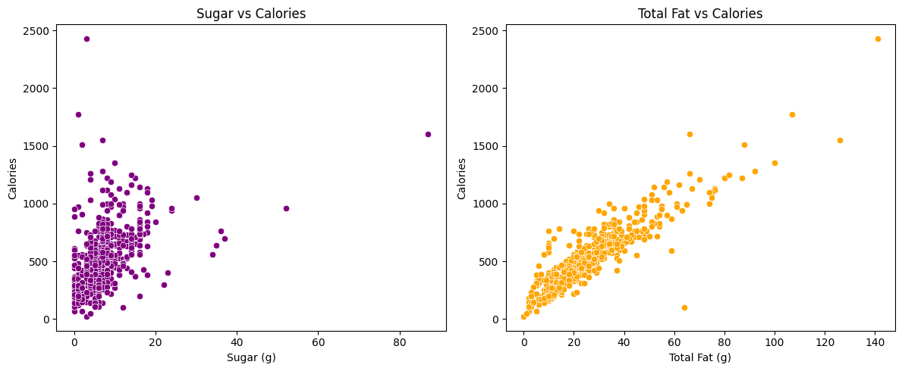
Technical Interpretation
- The subplot compares the relationship of two key nutrients (sugar and total fat) with calories side by side.
- Both plots show a positive relationship with calories.
- The total fat vs calories plot shows a stronger and steeper trend than sugar.
- A few outliers indicate food items extremely high in calories due to high nutrient content.
Objective-Oriented Interpretation
- Demonstrates that both sugar and fat contribute to calorie density, but fat has a greater impact.
- Helps identify nutritionally risky junk foods with high calorie contribution.
- Enables comparison of different nutritional drivers of calories within a single view.
Statistical Validation
The correlation patterns indicated numerically are visually validated by the positive relationships in the scatter subplots.

5.Protein vs Calories (Bubble Plot)
The bubble plot visualizes the relationship between protein and calorie content, with bubble size indicating magnitude.
Figure 23: Bubble Plot for Protein vs Calories
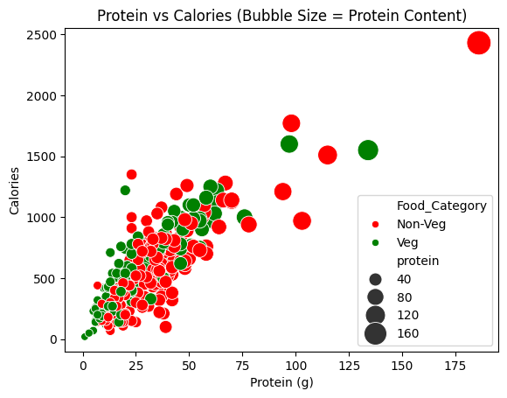
Technical Interpretation (Relationship & Distribution)
- Bubble size represents protein content, enabling multi-variable comparison.
- A general positive trend is observed: higher protein often corresponds to higher calories.
- Color coding differentiates Veg and Non-Veg food items.
Objective-Oriented Interpretation (Health & Nutrition Focus)
- Helps identify protein-rich junk food options and their calorie impact.
- Shows how protein–calorie patterns vary between Veg and Non-Veg foods.
- Supports assessment of nutritional density, not just calorie load.
Statistical Validation
The variation in protein contribution relative to calorie levels is visually supported by the bubble size distribution.
These Bivariate Analysis Chart Visualizations helped in identifying:
- Nutritional differences across categories
- Macro-nutrient contribution to calorie density
- Restaurant-wise variation
- Relationship strength between nutrients and calories
3.Multivariate Analysis
Multivariate analysis was performed to examine the interaction of multiple nutritional attributes simultaneously. This includes analyzing combined effects of macro and micro nutrients across restaurants and food categories. The goal is to identify complex patterns and derive deeper insights beyond individual or pairwise comparisons. The following multivariate visualizations were performed.
1.Heatmap – Micro & Macro Nutrient Correlation
The heatmap visualizes the correlation strength among multiple nutritional attributes.
Figure 24: Heatmap for Micro & Macro Nutrient Correlation
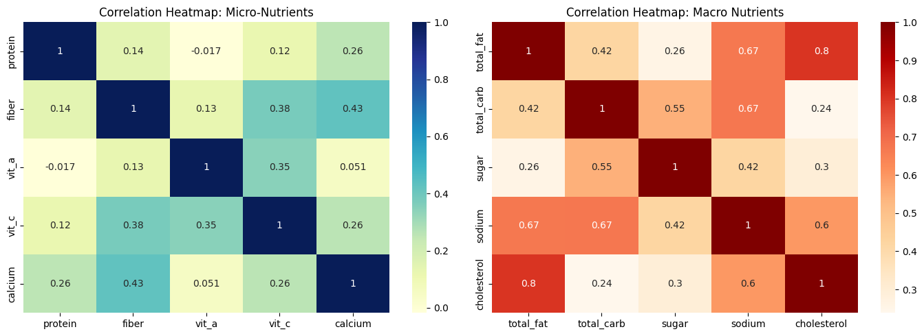
Technical Interpretation
- Micro-nutrient heatmap shows weaker to moderate correlations, indicating varied nutritional presence.
- Macro-nutrient heatmap shows stronger correlations, especially between fat, sugar, and cholesterol.
Objective-Oriented Interpretation
- Highlights that macro nutrients are closely linked, contributing jointly to calorie density.
- Micro-nutrients are less correlated, suggesting nutritional imbalance in junk food.
- Supports identification of nutritional patterns and variations across nutrient types.
- Helps distinguish energy-driving nutrients from health-supporting nutrients.
Statistical Validation
The statistical correlation measures are visually represented through intensity variations in the heatmap
2.Calories vs Micro vs Macro by Restaurant
This grouped chart compares calorie, macro-nutrient, and micro-nutrient values across restaurants.
Figure 25: Grouped Bar Chart for Calories vs Micro vs Macro by Restaurant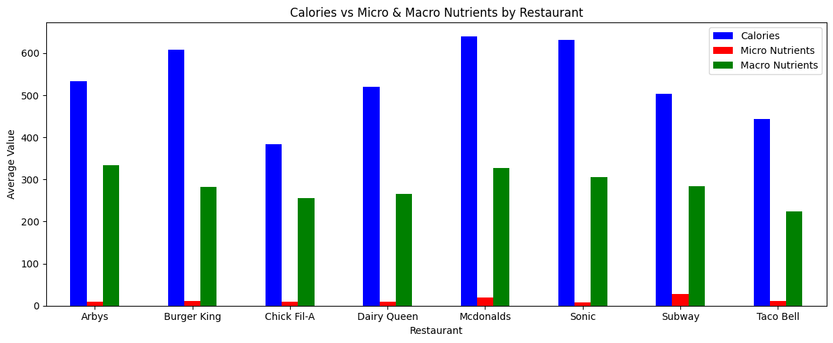
Technical Interpretation
- Micro and macro values are aggregated measures, enabling simplified comparison.
- Clear variation is observed in energy and nutrient profiles between restaurants
Objective-Oriented Interpretation
- Restaurants with higher calories often show higher macro-nutrient levels, indicating calorie-dense offerings.
- Micro-nutrient levels remain relatively low and similar across most restaurants
- Highlights the imbalance between energy intake and nutritional quality in junk food.
- Supports restaurant-wise nutritional comparison to identify healthier options.

Statistical Validation
The aggregated statistical differences across nutrients are visually reflected in the grouped multivariate comparison.
3. Calorie Level Distribution by Restaurant and Food Category
The stacked chart shows the distribution of calorie levels across restaurants and food categories
Figure 26: Calorie Level Distribution by Restaurant and Food Category
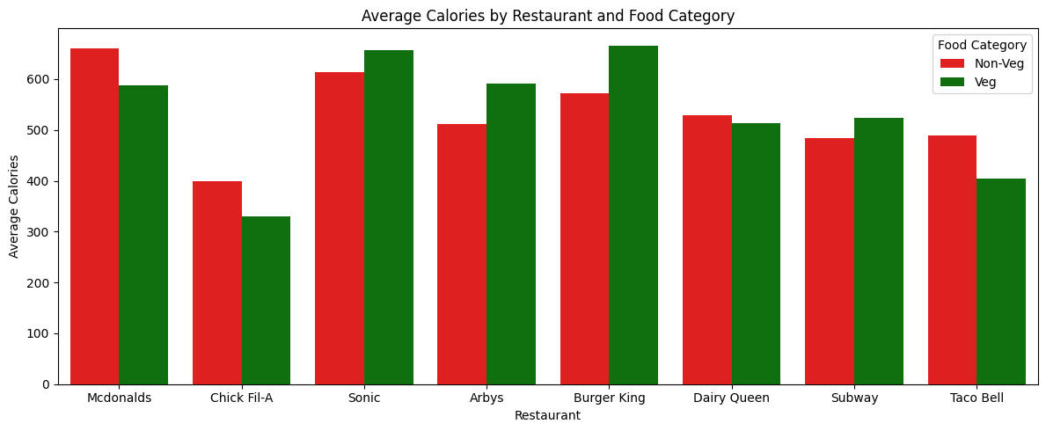
Technical Interpretation
- Uses grouped bars to compare average total fat for Veg and Non-Veg items by restaurant.
- Color coding (green for Veg, red for Non-Veg) enables easy category distinction.
- Bar height represents average total fat content per restaurant and food category.
- Rotated x-axis labels improve readability of restaurant names.

Objective-Oriented Interpretation
- Enables direct comparison of fat content between Veg and Non-Veg options across restaurants.
- Highlights restaurant-wise differences in average fat levels.
- Shows that Non-Veg items generally have higher fat, with some Veg exceptions.
- Supports informed dietary choices and fulfils the objective of comparing nutritional values across shops and categories.
Statistical Validation
The statistical category proportions are validated through the multivariate distribution plot
These Multivariate Analysis Chart visualizations enabled:
- Simultaneous comparison of multiple nutritional attributes
- Restaurant-wise nutritional profiling
- Category-wise calorie distribution analysis

10.Summary of Findings
- This project analyzed the nutritional composition of junk food items across different restaurants.
- The analysis revealed significant variation in calorie content, macro-nutrients (fat, sugar, sodium), and micro-nutrients (fiber, vitamins, calcium)
- While most items fall within low to medium calorie ranges, several high-calorie outliers were identified.
- Macro-nutrients showed strong positive relationships with calorie content, whereas micro-nutrients were relatively lower and less correlated.
- Restaurant-wise comparisons highlighted differences in nutritional profiles across brands

11. Key Insights
- Calorie distribution is positively skewed, indicating the presence of extreme high-calorie food items that elevate overall nutritional risk.
- Total fat and sugar exhibit strong positive relationships with calories, confirming their role as primary drivers of calorie density.
- Significant variability exists across restaurants, suggesting differences in nutritional formulation and menu strategies.
- Non-Veg food items generally demonstrate higher calorie concentration, though variation exists within both categories.
- Micro-nutrients contribute comparatively less to overall composition, highlighting nutritional imbalance within junk food items.
- Outlier detection confirms the presence of nutritionally extreme products, which may disproportionately affect consumer health if consumed frequently.

12.Types of Analysis
1.Descriptive Analysis: The following were performed for descriptive analysis
- Central tendency (mean, median, mode)
- Variance, standard deviation
- Skewness and kurtosis
- Distribution plots
Purpose: To summarize nutritional characteristics.
2.Diagnostic Analysis: The following were performed for diagnostic analysis
- Relationship analysis (Sugar vs Calories, Fat vs Calories)
- Category comparison (Veg vs Non-Veg)
- Restaurant-wise comparison
Purpose: To identify drivers of calorie density and nutritional imbalance.
3.Predictive Analysis (Scope for Future Work)
The following were performed as a part of Predictive analysis where the Correlation patterns between macro-nutrients and calories indicate strong predictive potential, suggesting that fat and sugar levels can help estimate calorie content. These findings provide a foundation for developing regression models to predict calorie levels in future work.
4.Prescriptive Analysis (Scope for Improvement) The following were performed for Prescriptive analysis
- Based on findings, healthier menu recommendations can be suggested.
- Nutritional reformulation strategies can be proposed for restaurants.

13.Recommendations
1.Business-Based Recommendations
- Menu Reformulation Strategy
Restaurants should consider reducing excessive fat and sugar content in high-calorie items to improve nutritional balance while maintaining taste.
- Nutritional Transparency Enhancement
Clear calorie labelling and nutrient breakdown should be prominently displayed to build consumer trust and regulatory compliance.
- Product Portfolio Diversification
Introduce healthier alternatives with improved micro-nutrient profiles to attract health-conscious consumers.
- Data-Driven Menu Optimization
Restaurants can leverage analytical insights to redesign menus based on nutritional performance and customer health trends.
- Competitive Benchmarking
Restaurants with higher average calorie offerings may evaluate competitor strategies to optimize product positioning.

2.Customer-Based Recommendations
- Prefer Lower Fat and Sugar Options
Consumers should select items with lower fat and sugar values to manage calorie intake effectively.
- Avoid Extreme High-Calorie Outliers
Frequent consumption of high-calorie items identified in the analysis may increase health risks.
- Examine Nutritional Labels Carefully
Understanding macro-nutrient composition helps make informed dietary decisions.
- Balance Diet with Micro-Nutrient Sources
Since junk food is low in micro-nutrients, consumers should complement their diet with nutrient-rich foods.
- Moderation in Consumption
Given the observed variability and calorie density, portion control and moderation are essential.

14.Future Enhancements
- The analysis can be extended to include more restaurants and food categories to improve comparison across shops.
- Additional micro-nutritional parameters can be included to better evaluate nutritional balance and unhealthy patterns.
- A basic predictive model can be developed to estimate calorie levels based on macro-nutrient values.
- The findings can be converted into an interactive dashboard to support easier decision-making and comparison.
- Customer preference data can be integrated to analyze how nutritional patterns influence food choices.
- Time-based data can be included to study trends in calorie and nutrient variation over time.

15.Conclusion

This study conducted a comprehensive statistical and visual analysis of junk food nutritional data across multiple restaurants. The findings reveal that calorie distribution is positively skewed, with several extreme high-calorie items significantly influencing overall variability.

Macro-nutrients such as total fat and sugar show strong positive relationships with calorie content, confirming their dominant role in determining energy density.

Micro-nutrients, including fiber and vitamins, demonstrate comparatively lower presence and variability, indicating nutritional imbalance in many junk food offerings.

Restaurant-wise comparison highlights noticeable differences in average calorie levels and nutrient composition, suggesting variation in menu formulation strategies across brands.

Overall, the analysis confirms that junk food items exhibit significant variability in nutritional quality, with macro-nutrient dominance and high-calorie outliers posing potential health concerns. The integration of statistical validation with univariate, bivariate, and multivariate visualizations provides a robust analytical foundation for decision-making.

